MASTERING DYNAMIC PROGRAMMING IN PYTHON
Master Dynamic Programming (DP) in DSA with Python — Complete Beginner-to-Advanced Roadmap
Since you know the basics of Python strings and arrays, you can start preparing for Dynamic Programming (DP). However, I recommend learning DP alongside the foundations of DSA rather than starting with difficult DP problems immediately.
DP is one of the most important problem-solving patterns for technical interviews at companies such as Google, Amazon, Microsoft, and other product-based companies. It also develops the algorithmic thinking useful in Data Science and Data Engineering.
Your goal should be to understand why a solution works, recognize when DP is appropriate, and independently solve unfamiliar problems—not simply memorize code.
1. What is Dynamic Programming?
Dynamic Programming is an algorithmic technique that solves a complex problem by breaking it into smaller subproblems, solving those subproblems once, and reusing their results.
Consider the Fibonacci sequence:
\[ F(n)=F(n-1)+F(n-2) \]
With \(F(0)=0\) and \(F(1)=1\), the sequence is:
0, 1, 1, 2, 3, 5, 8, 13, 21, ...
To calculate \(F(5)\), you need \(F(4)\) and \(F(3)\). But calculating \(F(4)\) recursively also requires \(F(3)\). The same work is repeated.
DP avoids unnecessary repeated calculations.
Why DP matters
Without DP
Exponential
Repeated calculations can make the runtime grow very quickly.
With DP
Linear
Fibonacci can be solved in O(n) time using stored results.
These complexities refer to the naive recursive Fibonacci algorithm versus a standard iterative DP implementation.
2. What should you learn before DP?
You do not need to master every DSA topic before beginning DP. But you should build a small set of foundations first.
Foundation | What you need to know
Python | Functions, loops, conditionals, lists, dictionaries
Arrays and strings | Indexing, slicing, traversing, comparing elements
Recursion | Base cases, recursive calls, call stack
Complexity | Big-O time and space complexity
Basic problem solving | Trace code manually and recognize repeated work
Most important prerequisite: recursion. You can understand recursion using Python even if you have never studied it formally.
For example:
def countdown(n): if n == 0: # Base case print(0) return print(n) countdown(n - 1) # Recursive callcountdown(3)
Output:
3
2
1
0
Learn how a recursive function reaches its base case and returns. You do not need to master complex recursion before starting beginner DP.
3. The four stages of solving a DP problem
Learn these four approaches in order. They are the foundation of almost every beginner DP lesson.
Stage 1 — Recursion
Break the problem into smaller versions of itself.
Ask: What smaller problem can solve this problem?
Stage 2 — Memoization (top-down DP)
Use recursion but cache the answers to subproblems.
Ask: Have I already solved this state?
Stage 3 — Tabulation (bottom-up DP)
Build a table from smaller states to larger states.
Ask: In what order should I fill the table?
Stage 4 — Space optimization
Keep only the previous results needed for the next calculation.
Ask: Do I need the entire table?
Let's learn these stages using one problem.
4. Your first DP problem: Fibonacci numbers
Step 1: Understand the problem
Given an integer n, return the nth Fibonacci number.
For example:
Input: n = 6
Output: 8
Why? Because:
F(0) = 0
F(1) = 1
F(2) = F(1) + F(0) = 1
F(3) = F(2) + F(1) = 2
F(4) = F(3) + F(2) = 3
F(5) = F(4) + F(3) = 5
F(6) = F(5) + F(4) = 8
Step 2: Solve using plain recursion
def fib(n): if n <= 1: return n return fib(n - 1) + fib(n - 2)print(fib(6))
Output:
8
This works, but it repeats calculations. For example, fib(3) gets calculated multiple times when calculating fib(5) and fib(6).
- Time complexity: \(O(2^n)\) as a simple upper bound.
- Space complexity: \(O(n)\) for the maximum recursion depth.
Step 3: Improve it with memoization
Memoization means storing answers in a dictionary so they can be reused.
def fib(n, memo=None): if memo is None: memo = {} if n <= 1: return n if n in memo: return memo[n] memo[n] = fib(n - 1, memo) + fib(n - 2, memo) return memo[n]print(fib(6))print(fib(10))
Output:
8
55
Now each Fibonacci state is computed only once.
- Time complexity: \(O(n)\).
- Space complexity: \(O(n)\), including the memo and recursion stack.
Notice this line:
if n in memo: return memo[n]
That is the heart of memoization.
Step 4: Solve using tabulation
Instead of calling the function recursively, build a list from the smallest answers upward.
def fib(n): if n <= 1: return n dp = [0] * (n + 1) dp[0] = 0 dp[1] = 1 for i in range(2, n + 1): dp[i] = dp[i - 1] + dp[i - 2] return dp[n]print(fib(6))
Output:
8
The DP array looks like this:
For n = 6
dp[0]
0
dp[1]
1
dp[2]
1
dp[3]
2
dp[4]
3
dp[5]
5
dp[6]
8
Each cell is calculated from the two cells immediately before it.
- Time complexity: \(O(n)\).
- Space complexity: \(O(n)\).
Step 5: Optimize the space
Do we need the whole list? No. Each new Fibonacci number requires only the previous two.
def fib(n): if n <= 1: return n prev2 = 0 prev1 = 1 for i in range(2, n + 1): current = prev1 + prev2 prev2 = prev1 prev1 = current return prev1print(fib(6))
Output:
8
- Time complexity: \(O(n)\).
- Auxiliary space complexity: \(O(1)\).
Your first milestone: Be able to explain all four approaches without looking at the solution. Then apply the same progression to Climbing Stairs.
5. The five questions you must ask for every DP problem
This is the most important problem-solving framework to learn. Do not start coding as soon as you read a question.
- What is the state?
What information uniquely identifies a smaller problem?
Example: dp[i] represents the Fibonacci number at index i.
- What is the transition?
How do I calculate the current answer using smaller states?
Example: dp[i] = dp[i - 1] + dp[i - 2].
- What are the base cases?
Which answers are already known?
Example: dp[0] = 0 and dp[1] = 1.
- What is the computation order?
Which states must be solved before another state can be calculated?
Example: calculate Fibonacci from index 2 upward.
- What is the final answer?
Which state contains the result?
Example: dp[n].
For optimization problems, also ask whether you need a minimum, maximum, number of ways, or a true/false answer.
6. How do you recognize a DP problem?
Look for these common clues:
Problem wording | Possible DP objective
Find the minimum cost | Minimize an accumulated cost
Find the maximum profit | Maximize a score
How many ways? | Count possible arrangements or paths
Is it possible to reach the target? | Boolean DP
Find the longest subsequence | Sequence DP
Choose items with a capacity limit | Knapsack DP
Compare two strings | String DP
A problem does not automatically require DP just because it asks for a minimum or maximum. Sometimes greedy algorithms, binary search, or other techniques are better.
The two properties that often make DP suitable are:
- Overlapping subproblems: the same smaller states recur.
- Optimal substructure: the larger answer can be built from answers to smaller states.
7. Complete DP syllabus: beginner to advanced
Follow this order. Each stage builds on the previous one, so you do not need to learn every pattern at once.
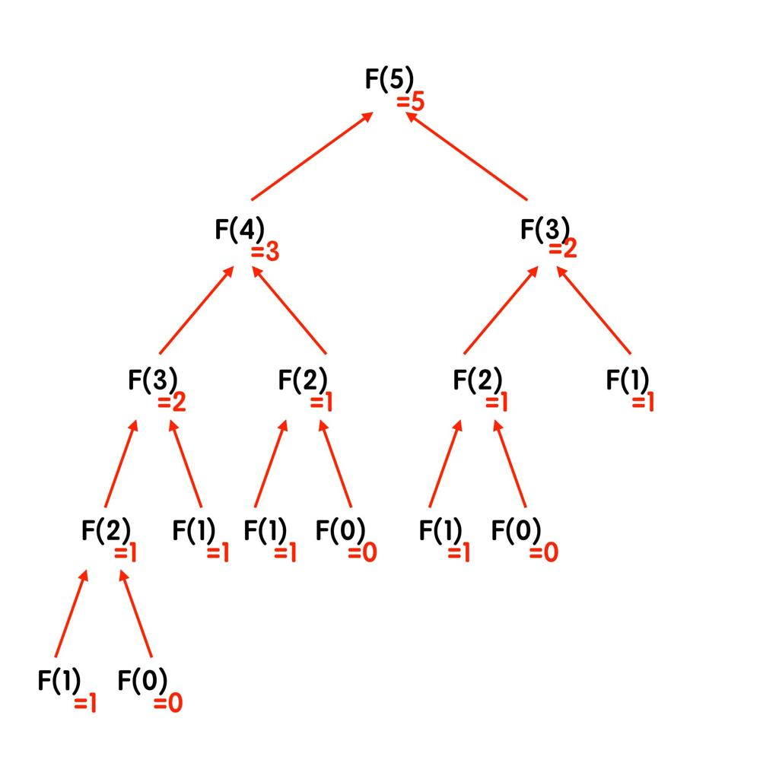
Level 1 — Recursion and 1D DP
Weeks 1–2
Learn recursion, memoization, tabulation, state transitions and space optimization.
Patterns: Fibonacci, climbing stairs, minimum cost, maximum sum.
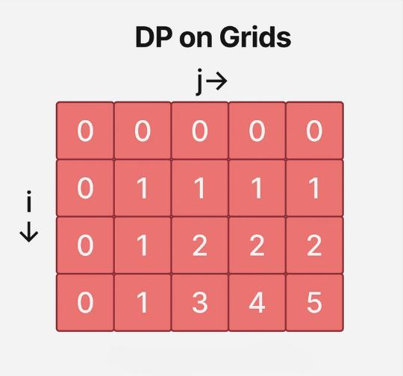
Level 2 — Grid and 2D DP
Weeks 3–4
Learn states using two indices, grid traversal, paths, obstacles and minimum costs.
Patterns: Unique Paths, Minimum Path Sum, Triangle.
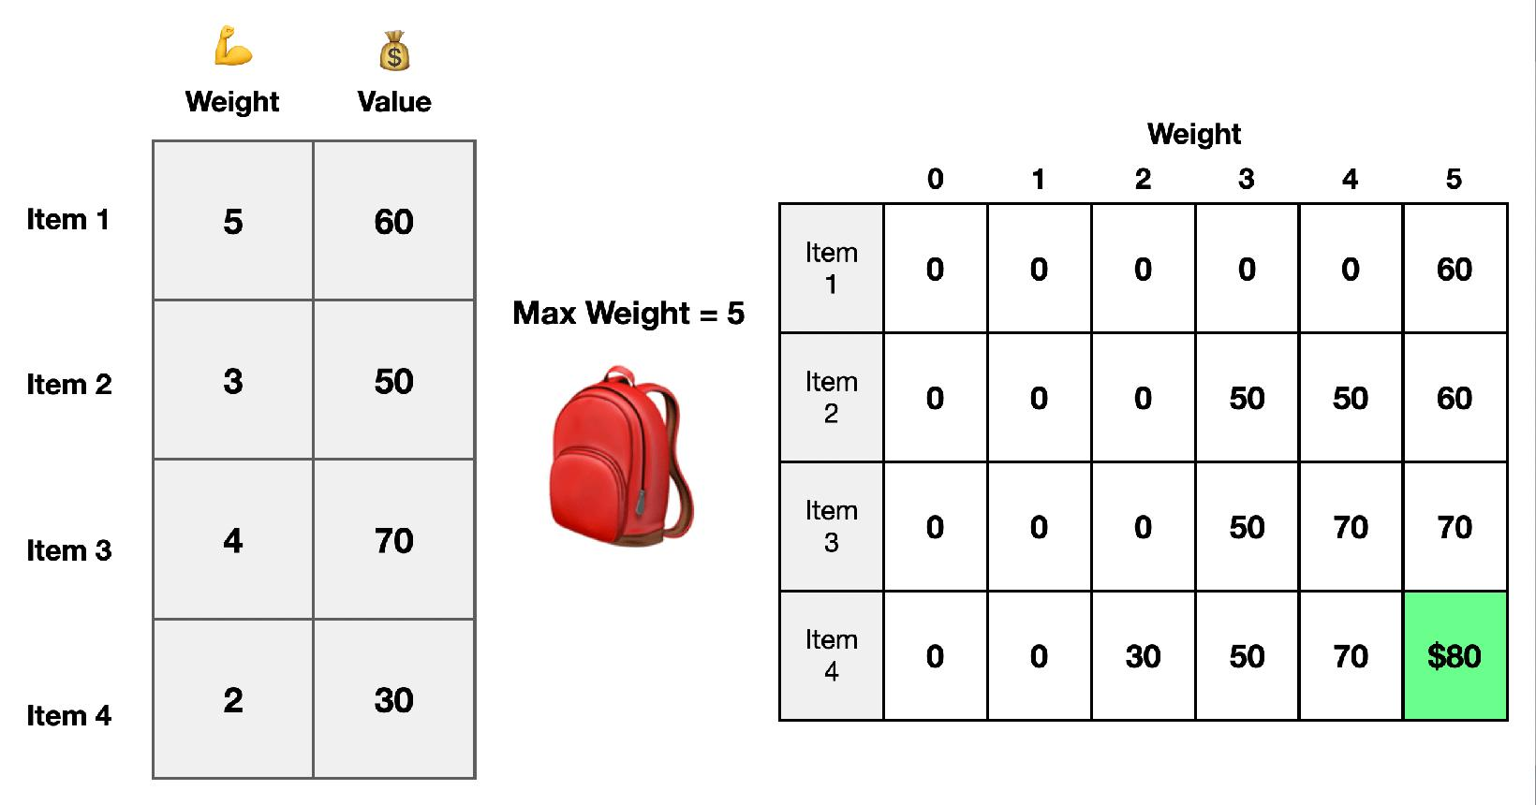
Level 3 — Knapsack and subset DP
Weeks 5–6
Learn take-or-skip decisions, capacity constraints, subset sums and counting combinations.
Patterns: 0/1 Knapsack, Coin Change, Partition Equal Subset Sum.
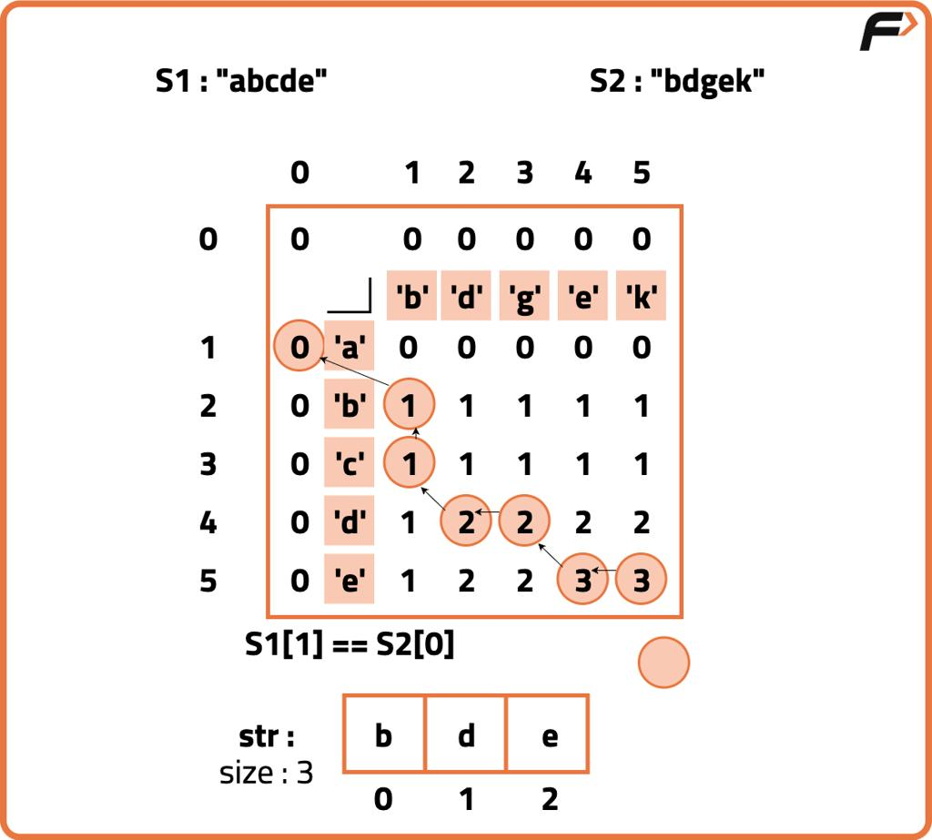
Level 4 — String and sequence DP
Weeks 7–8
Learn prefix comparisons, subsequences, sequence lengths and edit operations.
Patterns: LCS, LIS, Edit Distance, Palindromic Subsequence.
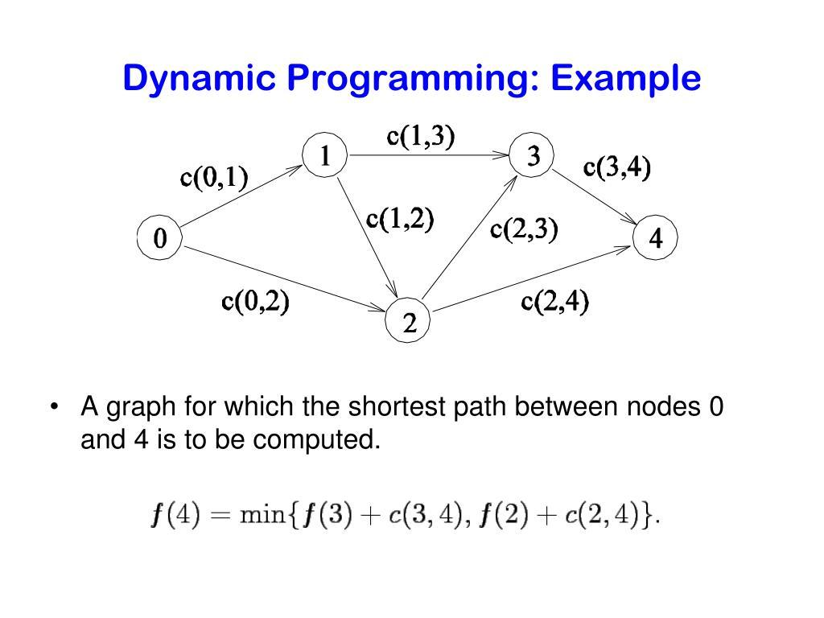
Level 5 — Advanced DP
Weeks 9–12+
Learn bitmask DP, interval DP, state-machine DP, tree DP and DP on graphs.
Patterns: Burst Balloons, stock trading variants, Traveling Salesperson, tree optimization.
This is an intensive 12-week learning path, not a guarantee of mastery in 12 weeks. If recursion or 1D DP is difficult, spend more time there before moving on.
8. The most important DP patterns and questions
Use this as your main syllabus. Solve the questions in the order shown, and revisit difficult ones rather than rushing through all of them.
Pattern A — Fibonacci and 1D DP
Goal: understand a state represented by a single index.
# | Problem | Difficulty
1 | Fibonacci Number | Easy
2 | Climbing Stairs | Easy
3 | N-th Tribonacci Number | Easy
4 | Min Cost Climbing Stairs | Easy
5 | House Robber | Medium
6 | House Robber II | Medium
7 | Decode Ways | Medium
8 | Maximum Subarray | Medium
9 | Jump Game | Medium
10 | Jump Game II | Medium
Key concept: Define what dp[i] means before writing the recurrence.
Pattern B — Grid and 2D DP
Goal: use two indices to represent positions in a grid.
# | Problem | Difficulty
11 | Unique Paths | Medium
12 | Unique Paths II | Medium
13 | Minimum Path Sum | Medium
14 | Triangle | Medium
15 | Maximal Square | Medium
16 | Minimum Falling Path Sum | Medium
Key concept: Usually, a cell depends on previously calculated neighboring cells. Check the permitted directions before choosing the transition.
Pattern C — Knapsack and subset DP
Goal: decide which items to select, omit, or combine.
# | Problem | Difficulty
17 | 0/1 Knapsack | Foundational
18 | Partition Equal Subset Sum | Medium
19 | Target Sum | Medium
20 | Coin Change | Medium
21 | Coin Change II | Medium
22 | Ones and Zeroes | Medium
23 | Last Stone Weight II | Medium
Key concept: Learn the difference between choosing each item at most once and choosing an item repeatedly. That distinction changes the DP transition and loop order.
Pattern D — Subsequences and string DP
Goal: solve problems involving sequences, prefixes, and comparisons.
# | Problem | Difficulty
24 | Longest Increasing Subsequence | Medium
25 | Longest Common Subsequence | Medium
26 | Longest Palindromic Subsequence | Medium
27 | Edit Distance | Medium
28 | Word Break | Medium
29 | Distinct Subsequences | Hard
30 | Regular Expression Matching | Hard
Key concept: Understand the difference between a substring, which is contiguous, and a subsequence, which can skip elements.
Pattern E — Stock and state-machine DP
# | Problem | Difficulty
31 | Best Time to Buy and Sell Stock | Easy
32 | Best Time to Buy and Sell Stock II | Medium
33 | Best Time to Buy and Sell Stock with Cooldown | Medium
34 | Best Time to Buy and Sell Stock with Transaction Fee | Medium
Key concept: A state may depend on your current situation, such as holding a stock, not holding a stock, or being in a cooldown period.
Pattern F — Advanced DP
# | Problem | Difficulty
35 | Burst Balloons | Hard
36 | Longest Increasing Path in a Matrix | Hard
37 | House Robber III | Medium
38 | Shortest Common Supersequence | Hard
39 | Traveling Salesperson Problem | Advanced
40 | Maximum Profit in Job Scheduling | Hard
Key concept: Some advanced problems need intervals, bitmasks, tree states or combinations of DP with other algorithms.
Problem difficulty labels can vary between platforms. The 40 questions above are a progression, not a list you must complete before applying for jobs.
9. Your 12-week study plan
Assume you can study around 60–90 minutes per day, five or six days per week. Since you are starting from basic arrays and strings, this plan includes a foundation phase.
Weekly progress tracker
0/12 weeks
Week 1: Recursion and complexity
Base cases, call stack, recursion trees, Big-O
Target: 6–8 exercises
Week 2: Memoization and tabulation
Fibonacci, Climbing Stairs, Tribonacci
Target: 5–7 problems
Week 3: 1D DP
Min Cost Climbing Stairs, House Robber, Maximum Subarray
Target: 5–7 problems
Week 4: More 1D DP
House Robber II, Decode Ways, Jump Game
Target: 5–7 problems
Week 5: 2D DP foundations
2D arrays, Unique Paths, grid transitions
Target: 5–6 problems
Week 6: Grid optimization
Minimum Path Sum, Triangle, obstacles
Target: 5–6 problems
Week 7: Knapsack
0/1 Knapsack, take/skip, capacity
Target: 4–6 problems
Week 8: Subset and coin DP
Partition Equal Subset Sum, Coin Change, Target Sum
Target: 5–6 problems
Week 9: Sequence DP
LIS, LCS, subsequences
Target: 4–6 problems
Week 10: String DP
Edit Distance, Word Break, palindromes
Target: 4–6 problems
Week 11: State-machine and tree DP
Stock variants, House Robber III
Target: 3–5 problems
Week 12: Revision and interview practice
Mixed unseen problems, explain solutions, optimize space
Target: 5–8 problems
Reset progress
Do not treat the problem targets as a race. If you can solve three problems independently and explain them correctly, that is better than copying ten solutions.
10. Your daily study routine
Here is a repeatable routine for each 60–90 minute session.
10 min
Recall yesterday's topic
Reproduce the recurrence or code from memory.
15 min
Learn one concept
Study one pattern and dry-run an example on paper.
25 min
Solve independently
Start with the recurrence and base cases. Write code only after you understand the transition.
15 min
Analyze and improve
Test edge cases, calculate complexity and compare memoization with tabulation.
10 min
Maintain a DP notebook
Record the state, transition, base cases, computation order and mistakes.
What if you cannot solve a question?
Use this process:
- Spend 20–30 minutes attempting it seriously.
- Write a brute-force or recursive solution first.
- Draw the repeated subproblems.
- Look at a hint or solution explanation, not just the final code.
- Close the solution and implement it yourself.
- Re-solve it the next day, then again after one week.
This repetition is essential because DP mastery comes from recognizing recurring structures across different questions.
11. Free resources to learn and practice
These are the resources I recommend using consistently rather than switching between many courses.

LeetCode
Best for structured practice and interview-style questions.
Start with the introductory DP problems before moving to advanced problems.
Official Dynamic Programming Study Plan

GeeksforGeeks
Useful for understanding concepts, studying recurrences, and practicing Python implementations.
Dynamic Programming tutorials
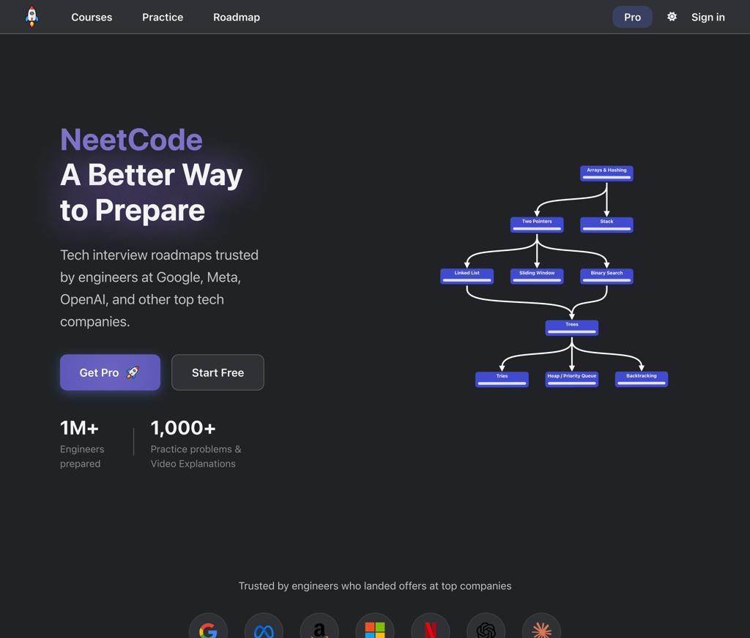
NeetCode
Helpful for visual explanations and recognizing problem patterns.
NeetCode practice roadmap

MIT OpenCourseWare
Use this later for more formal algorithm analysis and deeper theoretical understanding.
MIT OpenCourseWare
My recommended learning order is concept tutorial → hand-worked example → Python implementation → independent practice. LeetCode's own study plan encourages attempting problems first and then using official explanations to deepen understanding.

LeetCode
+1
12. Common mistakes beginners make in DP
Avoid these mistakes from the beginning.
- Memorizing code instead of understanding state. You should be able to explain what dp[i] represents in plain English.
- Jumping directly into Hard problems. Build confidence with Fibonacci, Climbing Stairs and House Robber first.
- Skipping recursion. Understanding the recursive relationship makes the DP transition easier to derive.
- Confusing subsequences with substrings. A subsequence can skip elements; a substring cannot.
- Getting the loop direction wrong in knapsack. In 0/1 knapsack, a capacity loop commonly runs backward when using a one-dimensional array. For unbounded knapsack, it often runs forward.
- Ignoring edge cases. Test empty inputs where permitted, a single element, zero capacity, unreachable targets and repeated values.
- Optimizing space too early. First make the full DP table work. Then optimize it.
- Reading solutions too quickly. A solution is not learned until you can reproduce it without looking.
13. Your first seven days: exact action plan
Start here rather than trying to learn all 40 questions immediately.
Week 1 checklist
0/7 complete
Day 1 — Learn recursion, base cases and call stack.
Write countdown, factorial and sum from 1 to n.
Day 2 — Learn recursion trees and repeated subproblems.
Implement Fibonacci using plain recursion.
Day 3 — Learn memoization with a Python dictionary.
Implement memoized Fibonacci and explain cache hits.
Day 4 — Learn tabulation using a list.
Implement iterative Fibonacci and dry-run n = 5.
Day 5 — Learn space optimization.
Implement Fibonacci with two variables.
Day 6 — Apply the pattern to a new problem.
Solve Climbing Stairs using recursion, memoization and tabulation.
Day 7 — Review and test your understanding.
Solve Climbing Stairs without notes and explain its complexity.
14. When can you consider yourself good at DP?
Measure progress by what you can do independently, not simply how many questions you have submitted.
- Beginner: You can explain recursion, memoization, tabulation and base cases.
- Intermediate: You can independently solve common 1D, grid and knapsack problems.
- Strong: You can identify states and transitions in string, subsequence and stock problems without needing a template.
- Interview-ready: You can solve unfamiliar medium-level problems, justify correctness, analyze complexity and explain trade-offs under time pressure.
- Advanced: You can derive solutions for unfamiliar interval, tree, bitmask and other advanced DP problems.
For technical interviews, aim to become consistently comfortable with the common patterns before focusing heavily on advanced DP. Mastery takes continued practice and revision, and the timeline varies by person.
Your first task
Begin with Fibonacci Number, then Climbing Stairs. For each problem, write four versions where applicable: recursion, memoization, tabulation and space-optimized DP.
Once you can derive the transition yourself, you will have learned something much more valuable than a single answer: a repeatable method for solving DP problems in Python.

